# Week 6.1

# Updates

## Component



## Game Object

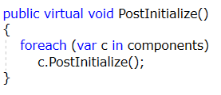

## Scene

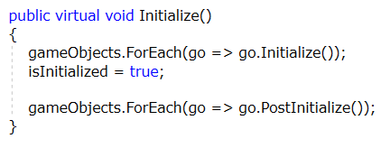

## Game Engine

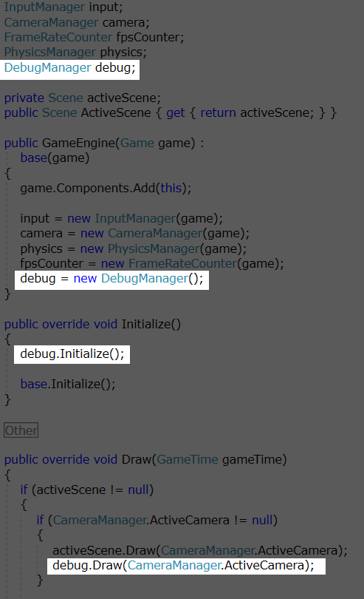

## Fixed Camera

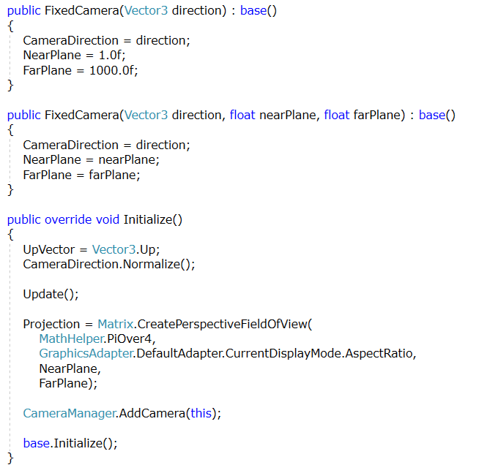

# New Classes

* Add DebugManager to the Managers folder of the Engine project
* Add ModelDataExtractor to the Engine project

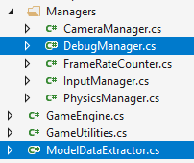

# Follow Along

* Follow along in class to setup the
  + Debugger component
  + Create BoundingBox for a model
  + Create Bounding Sphere for a model
  + Create Bounding Frustum for a camera
  + Rotate the camera with object